5.73: For a rope of length L, and weight w, assume that a length rL is on the table, so that a length 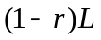 is hanging. The tension in the rope at the edge of the table is then 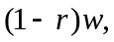 and the friction force on the part of the rope on the table is 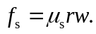 This must be the same as the tension in the rope at the edge of the table, so 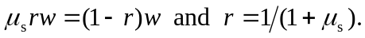 Note that this result is independent of L and w for a uniform rope. The fraction that hangs over the edge is 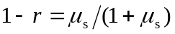; note that if 